Index

1. **Introduction**-------------------------------------------------------------------------------------------------**02** 
   1. Motivation
   2. Significance
   3. Objective
2. **Project Description**----------------------------------------------------------------------------------------**03**
3. **User Manual**------------------------------------------------------------------------------------------------**04**
4. **First increment**---------------------------------------------------------------------------------------------**09**
5. **Second increment**-----------------------------------------------------------------------------------------**12**
6. **Third increment**--------------------------------------------------------------------------------------------**16**
7. **Fourth increment**------------------------------------------------------------------------------------------**21**
8. **Challenges Faced**-------------------------------------------------------------------------------------------**32**
9. **Project Management**-------------------------------------------------------------------------------------**33**
10. **Project Deployment**---------------------------------------------------------------------------------------**36**
11. **Presentation Material**------------------------------------------------------------------------------------**37**
12. **Introduction**

**Motivation:**

2048 is played on a simple gray 4×4 grid, with numbered tiles that slide smoothly when a player moves them using the four gestures (left, right, top and bottom) Every turn, a new tile will randomly appear in an empty spot on the board with a value of either 2 or 4.Tiles slide as far as possible in the chosen direction until they are stopped by either another tile or the edge of the grid. If two tiles of the same number collide while moving, they will merge into a tile with the total value of the two tiles that collided. The resulting tile cannot merge with another tile again the same move. Higher-scoring tiles emit a soft glow. In order to make a good score in this game, player should follow some kind of pattern like focusing on only three motions i.e., always trying to avoid making one of the four motions.

**Significance**:

2048 is a puzzle game so by using this game we would be able to make some predections of player’s mentality. In 2048 we have used five movements left, right, up, down and restart and used sensor tag to decide which movements are made based on the gestures made by the player.

**Objective:**

The main objective is drawing a sketch of the user mentality on how does he/she treats a problem. How safe sided is the approach taken or how conventional is the problem solving technique. In order to do this we use the motion sensor and build a 2048 android application using the large amount of data generated by the motion sensor i.e., sensor tag and use the data provided by the motion sensor to decide the mood of the player who is playing i.e., he is upset or calm. The game would give out a report with all these calculations of the predictability of user’s move on the basis of previous move.

For this to achieve we first have to train our system by taking different sample players and ask them to play the game and try to solve it completely. This would be primary data for our machine learning algorithm. We plan on training the system with at least 10-20 players playing the game at least 5-10 times to capture as many possible cases in between the game that different people could take different ways around it.

On top of this data we would define a set of rules and trends to define a person’s mentality depending on the stage at which the player is making the move. We are considering the level as well in which the move is being made cause in the earlier stages of the game it is quite simple to add up the numbers and the plan of any player would show his own mark when compare to others from a particular stage of the game.

1. **Project Description**

**System Features:**

* Android Development Tool(4.4 version)
* Eclipse ADT

**Online Application: Game by Motion**

**Devices/Sensors**

Sensor tag is used as a motion sensor to play the 2048 game in android device (Nexus).



* Our Project mainly focusses on usage of 2048 android application.
* The data is trained by using K-Means and Hidden Makarov Model.
* Sensor tag will generate the data about the moves made by user.
* Testing is done based on the probability of the move made by the user with the help for training data.
* We generate pie chart and line chart based on the data generated by playing the game.

1. **User Manual**

The app shows the opening screen with the buttons play game, pie chart, line chart as shown below.



When we click play game the game starts. The game screen looks as below.

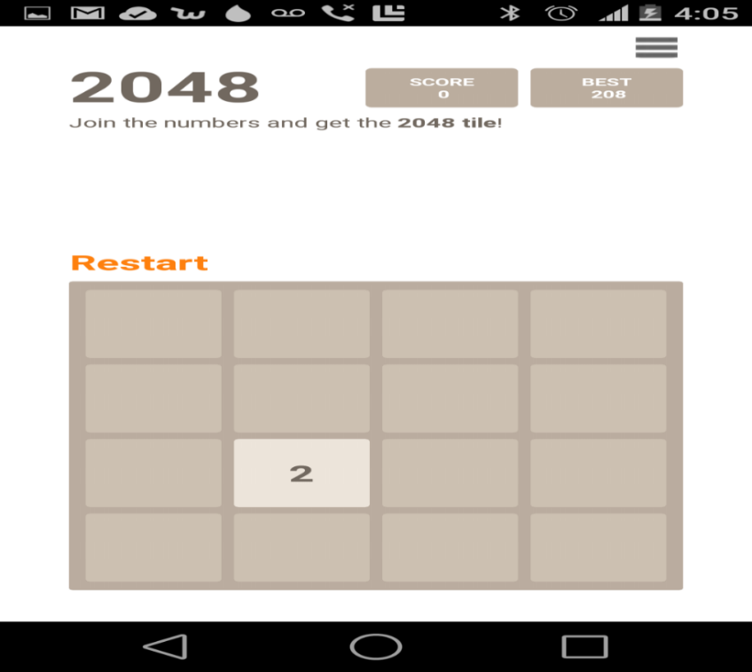

* To play the 2048 follow the listed instructions:

1. Same numbers can be added.
2. Adding the same numbers will increase the score.
3. To add the numbers:
4. You can make a right move by moving the sensor tag facing right.
5. You can make a left move by moving the sensor tag facing left.
6. You can make up move by moving the sensor tag facing upwards.
7. You can make a down move by moving the sensor tag facing downwards.
8. You should add up the numbers in a pattern so as to make the largest possible tile.
9. The game continues until you have a chance to make a move.
10. You can restart the game at any point of time by making a punch gesture.

* Once you are done with the game, the game over screen appears as shown.

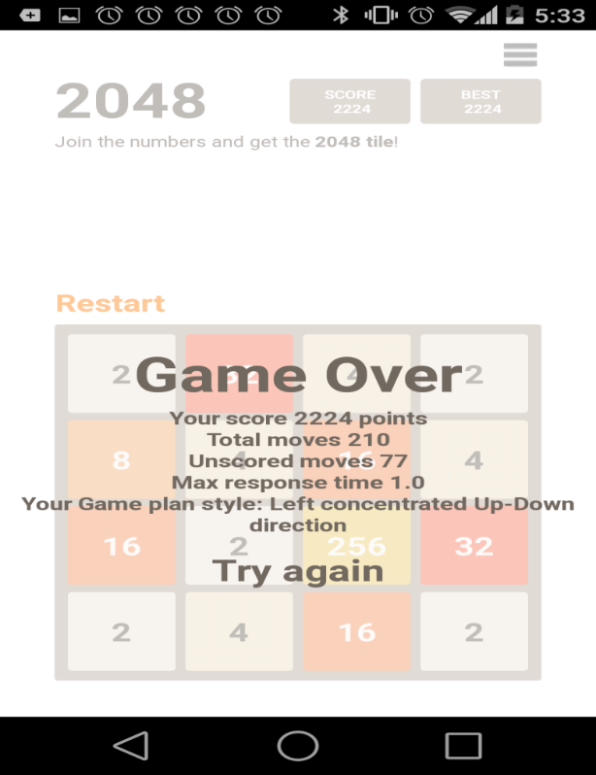

* It shows your score where the following will let you know

1. Total moves: Total number of moves made by you.
2. Unscored moves: The plain moves made by you with out any additions made.
3. Maximum response time: The average of three maximum response times that you took to make a move.
4. Game plan style: The gesture being used the most.

Also you can see your statistics by choosing pie chart and line chart buttons.

* On clicking pie chart button the following screen appears.

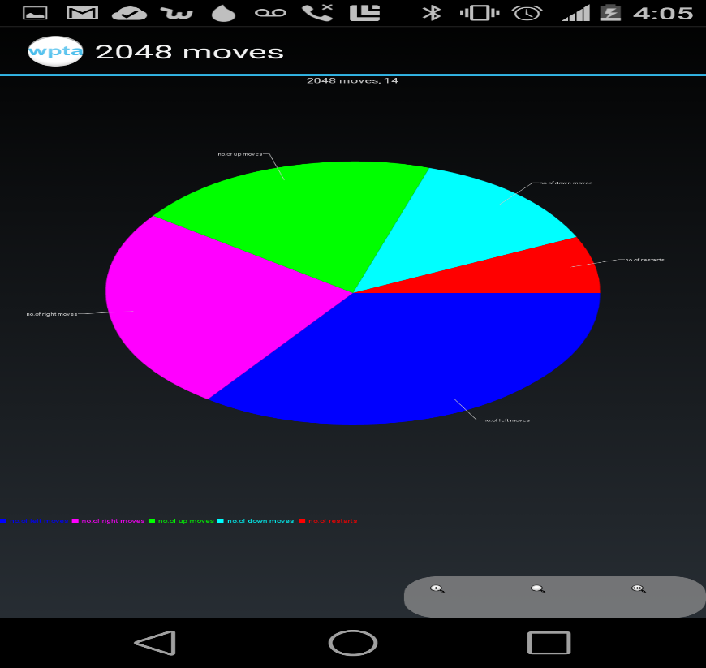

This gives you the statistical information of number of left, right, up, down and restarts made by you differentiating each gesture by a particular color.

* On clicking the line chart button you will get the following screen.

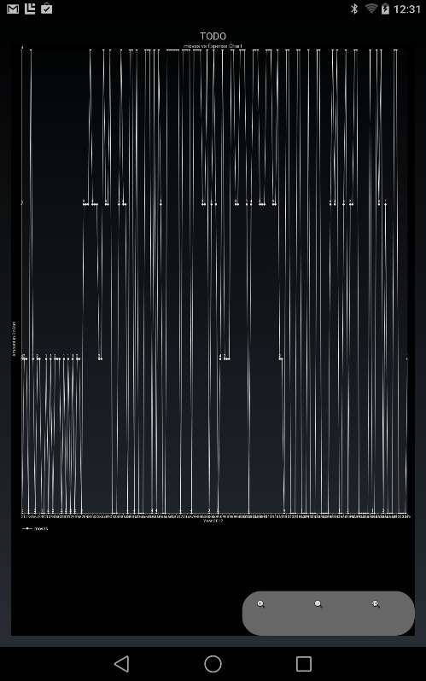

* The x-axis here shows the number of attempt and the y-axis shows the type of the move with each number depicting a particular move.

1. **First increment**

**Introduction**

The primary goal of our project is to extend the existing 2048 game which is a touch based game app and implement the same as a gesture based game app. The game uses the gyroscope sensors on the user’s smartphones to recognize the direction in which the user wants to add up the numbers to achieve the target of 2048.

The game would record all the user moves and the plan with which the user tries to solve the 2048 and would calculate the predictability of the user moves and the risk taking factor of the user.

**Project goal and Objective**

The main objective is drawing a sketch of the user mentality on how does he/she treats a problem. How safe sided is the approach taken or how conventional is the problem solving technique. In order to do this we use the motion sensor and build a 2048 android application using the large amount of data generated by the motion sensor i.e., sensor tag and use the data provided by the motion sensor to decide the mood of the player who is playing i.e., he is upset or calm. The game would give out a report with all these calculations of the predictability of user’s move on the basis of previous move.

For this to achieve we first have to train our system by taking different sample players and ask them to play the game and try to solve it completely. This would be primary data for our machine learning algorithm. We plan on training the system with at least 10-20 players playing the game at least 5-10 times to capture as many possible cases in between the game that different people could take different ways around it.

On top of this data we would define a set of rules and trends to define a person’s mentality depending on the stage at which the player is making the move. We are considering the level as well in which the move is being made cause in the earlier stages of the game it is quite simple to add up the numbers and the plan of any player would show his own mark when compare to others from a particular stage of the game.

**Project Background and related work**

* 2048 (open source android game)
* Sensor tag (Open source Android application)

**Proposed System:**

* Our Project mainly focusses on usage of 2048 android application.
* The data obtained from training will be stored in the Hbase (solr).
* Sensor tag is used as a motion sensor to play the game.
* Sensor tag will generate the data about the moves made by user.
* Mahout will be used to provide the Players mood by analyzing the recommendations from the trained data.
* Web services will be used to display the relevant information obtained from solr.

**Technological and Architectural requirements**

● Cloudera Virtual Machine and Hadoop tools

● Hadoop

● HBase

● Mahout

● Solr

● Solr’s RESTful services

● Android Developers Tools

**Architecture diagram**

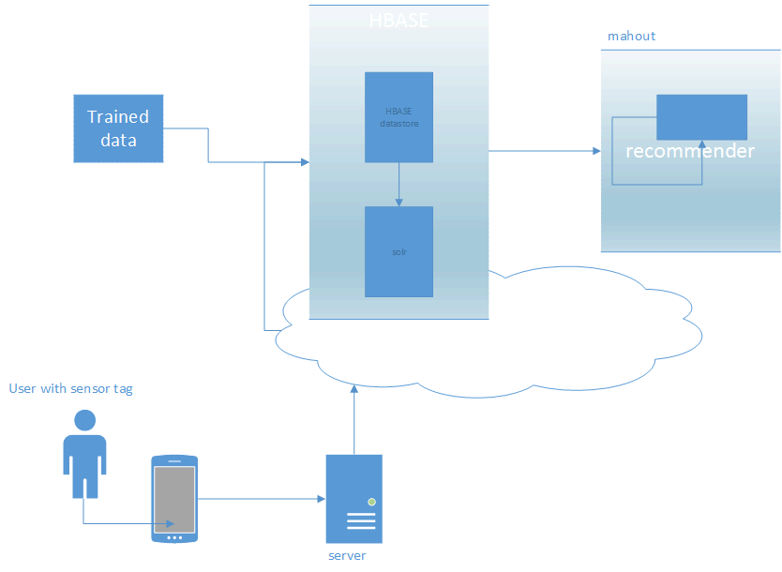

**Github**

<https://github.com/mlikk/BigDATA/tree/master/Project_2048/Project%20proposal>

**Bibliography**

<http://processors.wiki.ti.com/index.php/SensorTag_User_Guide>

<http://en.wikipedia.org/wiki/2048(video_game)>

<https://github.com/uberspot/2048-android>

<https://play.google.com/store/apps/details?id=com.digiplex.game>

1. **Second increment**

**Introduction**

The primary goal of our project is to extend the existing 2048 game which is a touch based game app and implement the same as a gesture based game app. The game uses the gyroscope sensors on the user’s smartphones to recognize the direction in which the user wants to add up the numbers to achieve the target of 2048.

The game would record all the user moves and the plan with which the user tries to solve the 2048 and would calculate the predictability of the user moves and the risk taking factor of the user.

**Project goal and Objective**

The main objective is drawing a sketch of the user mentality on how does he/she treats a problem. How safe sided is the approach taken or how conventional is the problem solving technique. In order to do this we use the motion sensor and build a 2048 android application using the large amount of data generated by the motion sensor i.e., sensor tag and use the data provided by the motion sensor to decide the mood of the player who is playing i.e., he is upset or calm. The game would give out a report with all these calculations of the predictability of user’s move on the basis of previous move.

For this to achieve we first have to train our system by taking different sample players and ask them to play the game and try to solve it completely. This would be primary data for our machine learning algorithm. We plan on training the system with at least 10-20 players playing the game at least 5-10 times to capture as many possible cases in between the game that different people could take different ways around it.

On top of this data we would define a set of rules and trends to define a person’s mentality depending on the stage at which the player is making the move. We are considering the level as well in which the move is being made cause in the earlier stages of the game it is quite simple to add up the numbers and the plan of any player would show his own mark when compare to others from a particular stage of the game.

**Project Background and related work**

* 2048 (open source android game)
* Sensor tag (Open source Android application)

**Technological and Architectural requirements**

● Cloudera Virtual Machine and Hadoop tools

● Hadoop

● HBase

● Mahout

● Solr

● Solr’s RESTful services

● Android Developers Tools

**Architecture diagram**



* Our Project mainly focusses on usage of 2048 android application.
* The data is trained by using K-Means and Hidden Makarov Model.
* Sensor tag will generate the data about the moves made by user.
* Testing is done based on the probability of the move made by the user with the help for training data.
* We generate pie chart and line chart based on the data generated by playing the game.

This is the code for the 2048 game view where view contain the board with 4*4 cells

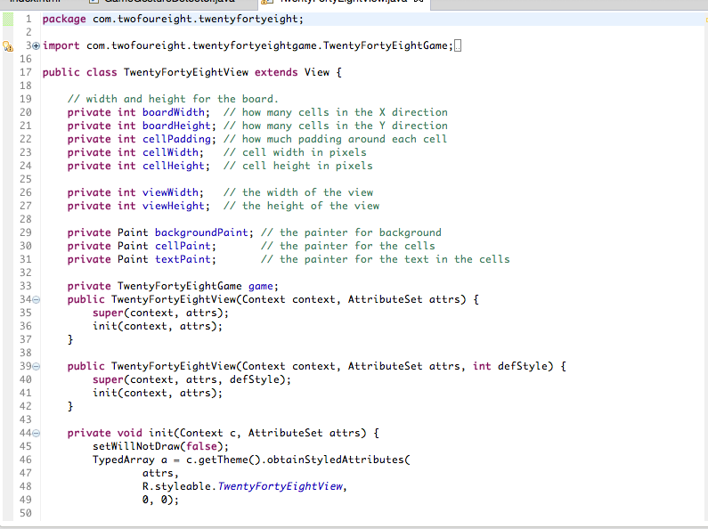

This will be the view of the game

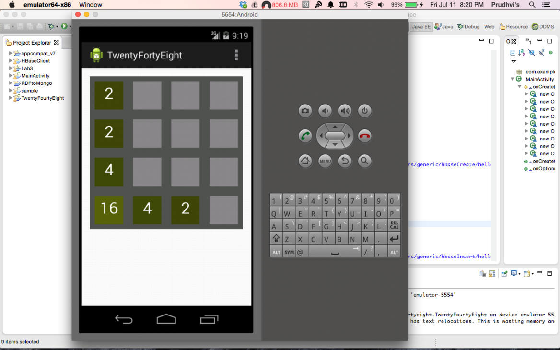

Below is our code to collect the training data

Boolean gesture = false;

StringBuffer buffer = new StringBuffer();

private void whichGesture(ArrayList<String> datapointsList) throws Exception {

for (int i = 0; i < datapointsList.size(); i++) {

buffer.append(datapointsList.get(i));

}

buffer.append(System.getProperty("line.separator"));

SaveData(buffer.toString());

buffer.delete(0, buffer.length());

}

private void SaveData(String string) {

// Log.i("string", string);

File sdCard = Environment.getExternalStorageDirectory();

File directory = new File (sdCard.getAbsolutePath() + "/Data");

if(!directory.exists())

directory.mkdirs();

String fname = fileName;

File file = new File (directory, fname);

try {

if(!file.exists()) file.createNewFile();

FileOutputStream out = new FileOutputStream(file,true);

out.write(string.getBytes());

out.flush();

out.close(); }

catch (Exception e)

{ e.printStackTrace();

}

}

}

**Github :**<https://github.com/mlikk/BigDATA/tree/master/Project_2048/Project%20increment2>

**Bibliography**

<http://processors.wiki.ti.com/index.php/SensorTag_User_Guide>

<http://en.wikipedia.org/wiki/2048(video_game)>

<https://github.com/uberspot/2048-android>

<https://play.google.com/store/apps/details?id=com.digiplex.game>

1. **Third increment**

**Design and Implementation of Mobile Client:**

2048 is played on a simple gray 4×4 grid, with numbered tiles that slide smoothly when a player moves them using the four gestures (left, right, top and bottom) Every turn, a new tile will randomly appear in an empty spot on the board with a value of either 2 or 4.Tiles slide as far as possible in the chosen direction until they are stopped by either another tile or the edge of the grid. If two tiles of the same number collide while moving, they will merge into a tile with the total value of the two tiles that collided. The resulting tile cannot merge with another tile again the same move. Higher-scoring tiles emit a soft glow.

This is the code for the 2048 game view where view contain the board with 4*4 cells



This will be the view of the game



This is the code inorder to detect the moves and respond to the moves whether to right, left, top or down. This is the code we edited to detect and respond to the sensor moves.

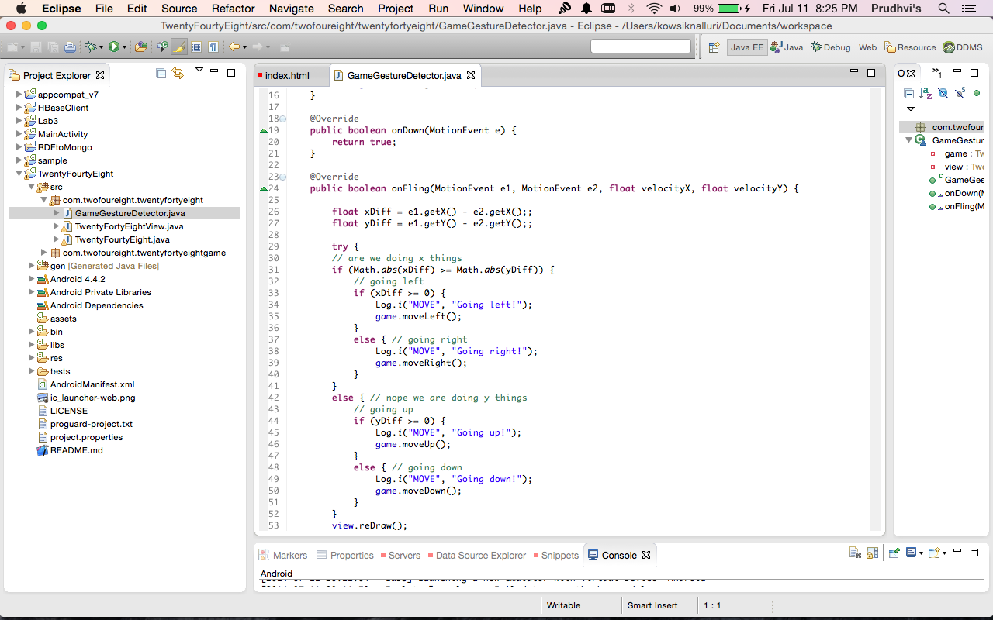

**Design and Implementation of Big Data Analytics:**

For the Activity Recognition made by the sensors, we have taken the data from the sensor and collected the data for each move(left, right, Top, bottom) for 5 times and tranied the data by using the HMMWS model available in blackboard and pushed into the cloudera group floder convert the data into the sequence files using the Restful service given in the lab 4. Now we can detect which action is performed.

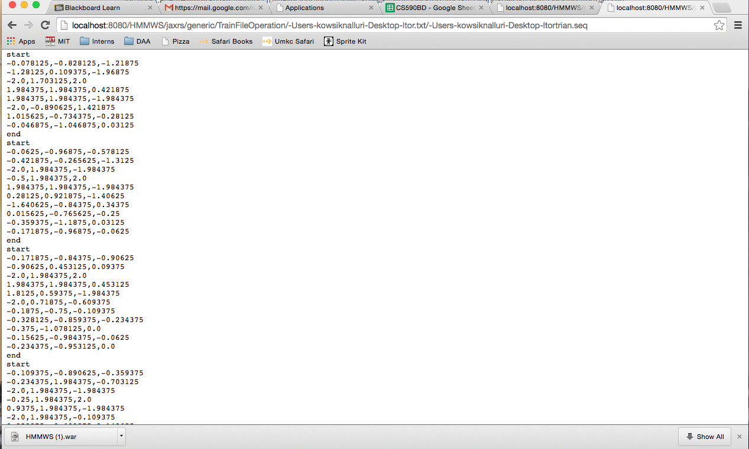

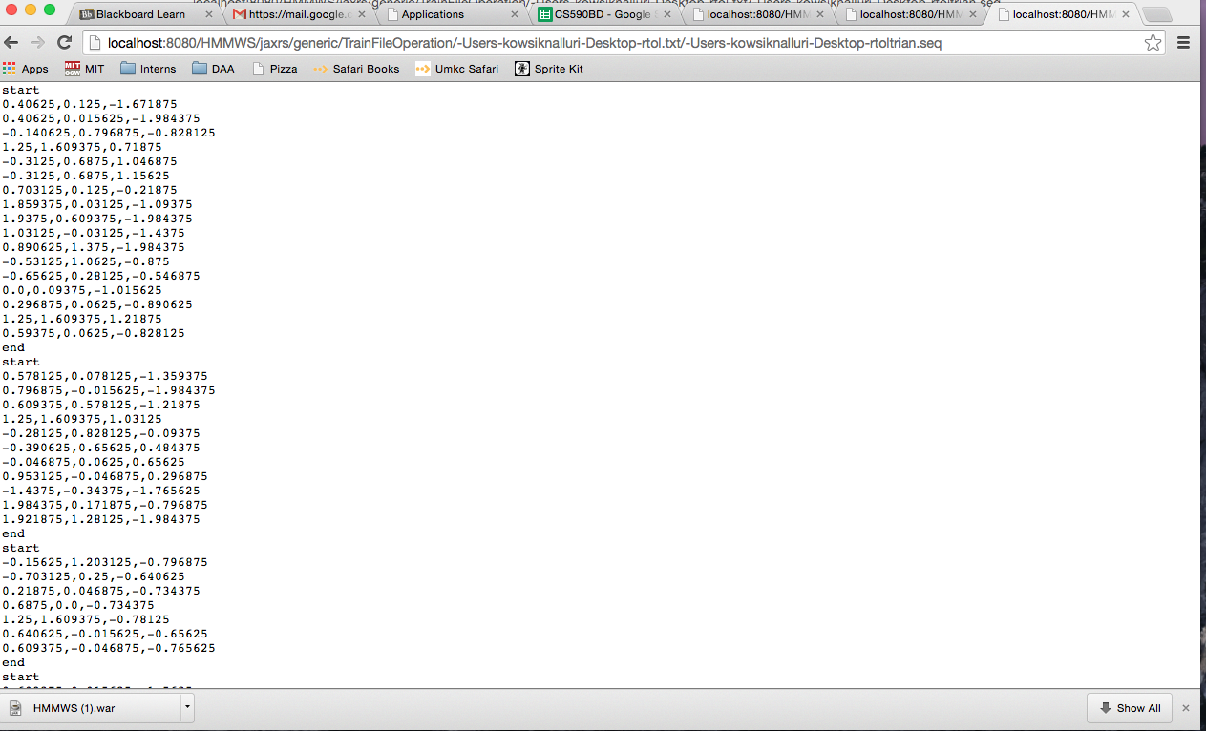

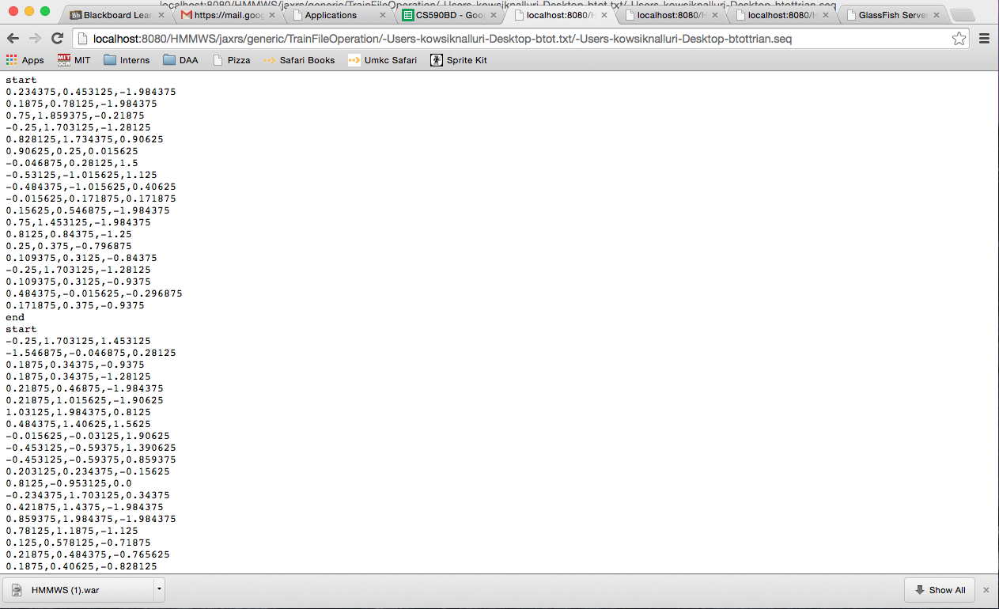

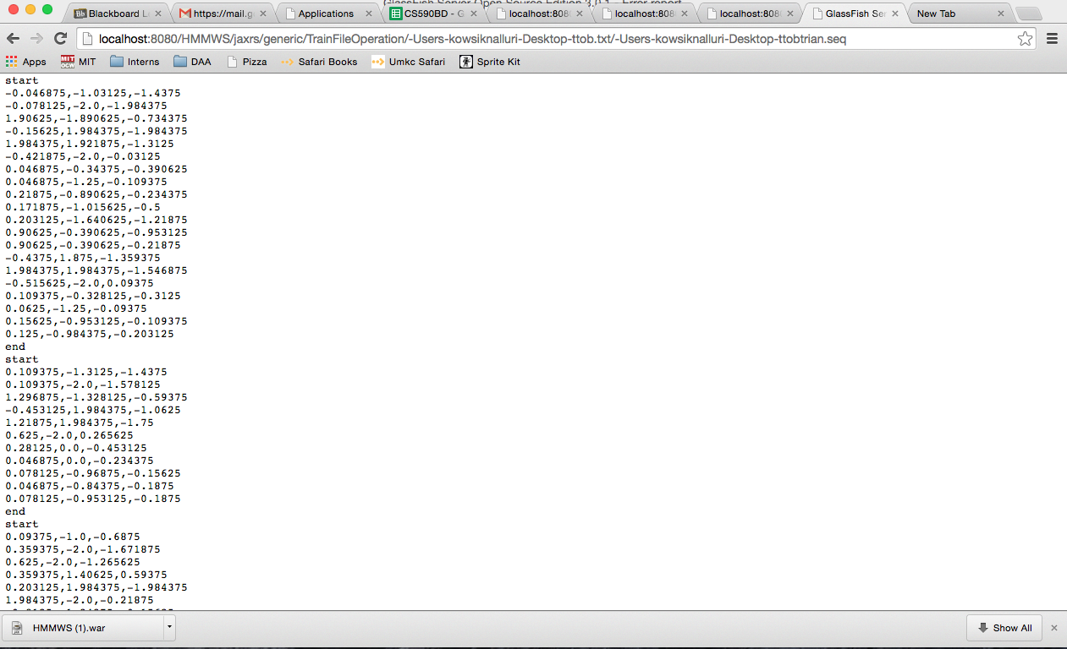

the seqeunce files are generated and test file is also created now we can detect which action is performed by the user.

**Future Work:**

Our future work is to delvelop the game to respond to live actions performed by the user and we have to take some more data for each action inorder to gain accuracy.

**Github**

https://github.com/PrudhviNalluri/CS5590BD/tree/master/Project%20Increment%203

**Bibliography**

<http://processors.wiki.ti.com/index.php/SensorTag_User_Guide>

<http://en.wikipedia.org/wiki/2048(video_game)>

<https://github.com/uberspot/2048-android>

<https://play.google.com/store/apps/details?id=com.digiplex.game>

<https://github.com/mripley/TwentyFortyEight>

1. **Fourth increment**

**Project Goal and Objectives**

**Motivation:**

2048 is played on a simple gray 4×4 grid, with numbered tiles that slide smoothly when a player moves them using the four gestures (left, right, top and bottom) Every turn, a new tile will randomly appear in an empty spot on the board with a value of either 2 or 4.Tiles slide as far as possible in the chosen direction until they are stopped by either another tile or the edge of the grid. If two tiles of the same number collide while moving, they will merge into a tile with the total value of the two tiles that collided. The resulting tile cannot merge with another tile again the same move. Higher-scoring tiles emit a soft glow. In order to make a good score in this game, player should follow some kind of pattern like focusing on only three motions i.e., always avoid making one of the four motions.

**Significance**:

2048 is a puzzle game so by using this game we would be able to make some predections of player’s mentality. In 2048 we have used five movements left, right, up, down and restart and used sensor tag to decide which movements are made based on the gestures made by the player.

**Objective:**

The main objective is drawing a sketch of the user mentality on how does he/she treats a problem. How safe sided is the approach taken or how conventional is the problem solving technique. In order to do this we use the motion sensor and build a 2048 android application using the large amount of data generated by the motion sensor i.e., sensor tag and use the data provided by the motion sensor to decide the mood of the player who is playing i.e., he is upset or calm. The game would give out a report with all these calculations of the predictability of user’s move on the basis of previous move.

For this to achieve we first have to train our system by taking different sample players and ask them to play the game and try to solve it completely. This would be primary data for our machine learning algorithm. We plan on training the system with at least 10-20 players playing the game at least 5-10 times to capture as many possible cases in between the game that different people could take different ways around it.

On top of this data we would define a set of rules and trends to define a person’s mentality depending on the stage at which the player is making the move. We are considering the level as well in which the move is being made cause in the earlier stages of the game it is quite simple to add up the numbers and the plan of any player would show his own mark when compare to others from a particular stage of the game.

**System Features:**

* Android Development Tool(4.4 version)
* Eclipse ADT

**Online Application: Game by Motion**

**Devices/Sensors**

Sensor tag is used as a motion sensor to play the 2048 game in android device (Nexus).



* Our Project mainly focusses on usage of 2048 android application.
* The data is trained by using K-Means and Hidden Makarov Model.
* Sensor tag will generate the data about the moves made by user.
* Testing is done based on the probability of the move made by the user with the help for training data.
* We generate pie chart and line chart based on the data generated by playing the game.

**Recognition/Analysis Approaches**

In the 2048 project we have created main_activity.java which will invoke the connection service for the sensor tag by calling connection service.java where different sensors like accelerometer, humidity of the sensor tag can be enabled and functions were written to collect data and the collected data is modified to standard accelerometer or humidity data by using sensordata.java. An object of Testgesture is created and Train method is called using this object after getting connected to sensor tag. Here we have used **HMM training algorithm** to train the data. After training is done we will call Test method using the Testgesture object and will find what kind of motion our sensor tag represent by comparing with the probabilities of all motions and broadcast the motion with maximum probability. The below given code is for broadcasting motion.

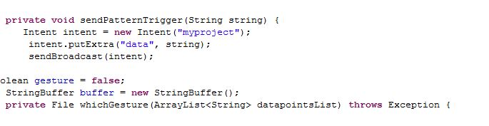

* Below given code is of Test method in Testgesture.java which will find what kind of motion our sensor tag represent by comparing with the probabilities of all motions

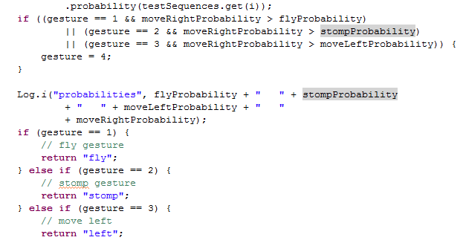

In main_activity.java we will receive the broadcasted motion from Connectionservice.java and make the necessary movement in the 2048 game. Below code for receiving broadcasted data and making necessary changes in 2048.

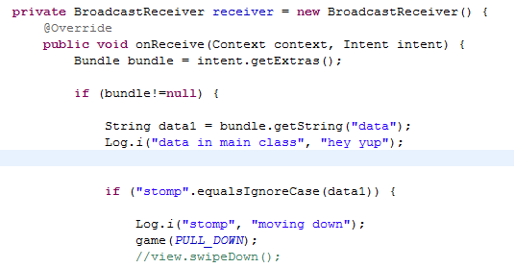

**System Features and Android App GUI**

Below figure is the main screen of 2048 app where we have 2 buttons. 2048-game button will take us to 2048 game and the pie chart button will take us to the piechart of number of left, right, top, bottom, restart moves.



**2048 game**

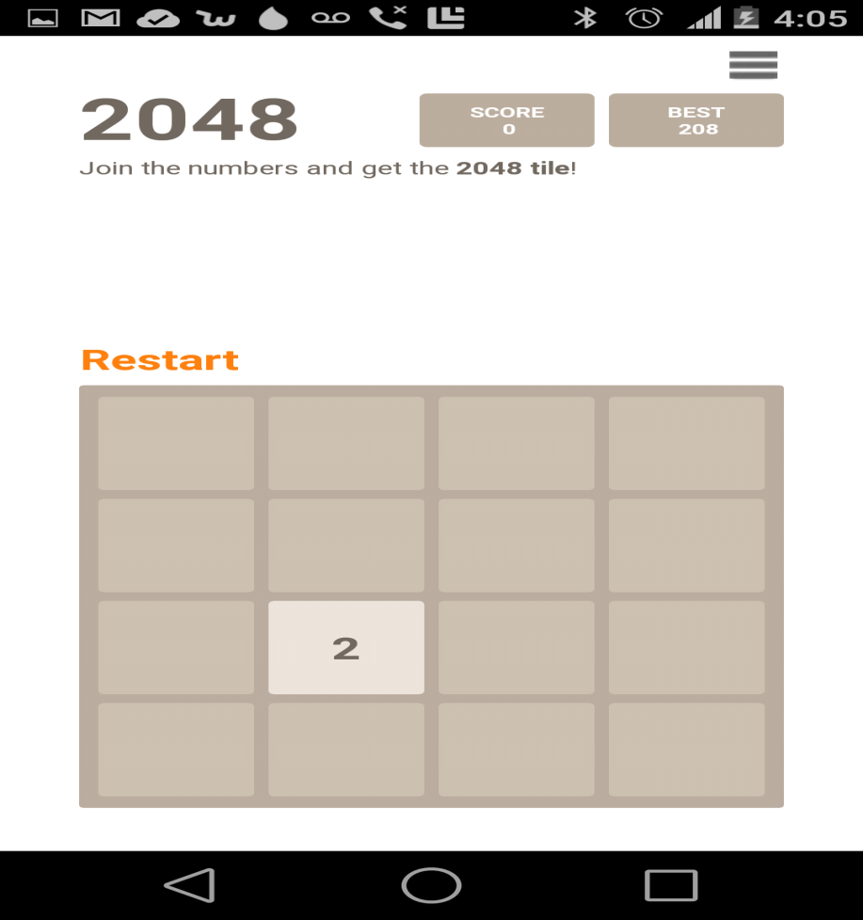

**Offline Application: Activity Report**

When 2048 game is running in background we are capturing moves which we are making along with the move and the score which we obtained by making that move. After the game we are making some evaluations and some graphs based on the data obtained.

Below figure is the data which we obtained after playing the game.

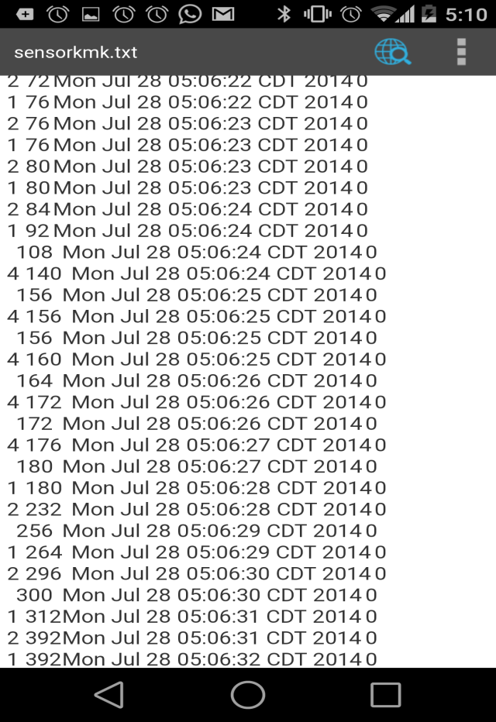

From the data which we obtained from the game were able to draw a pie diagram and line diagram by counting the number of left, right, up, down, restart moves in order to get the visual representation of analysis which we make.

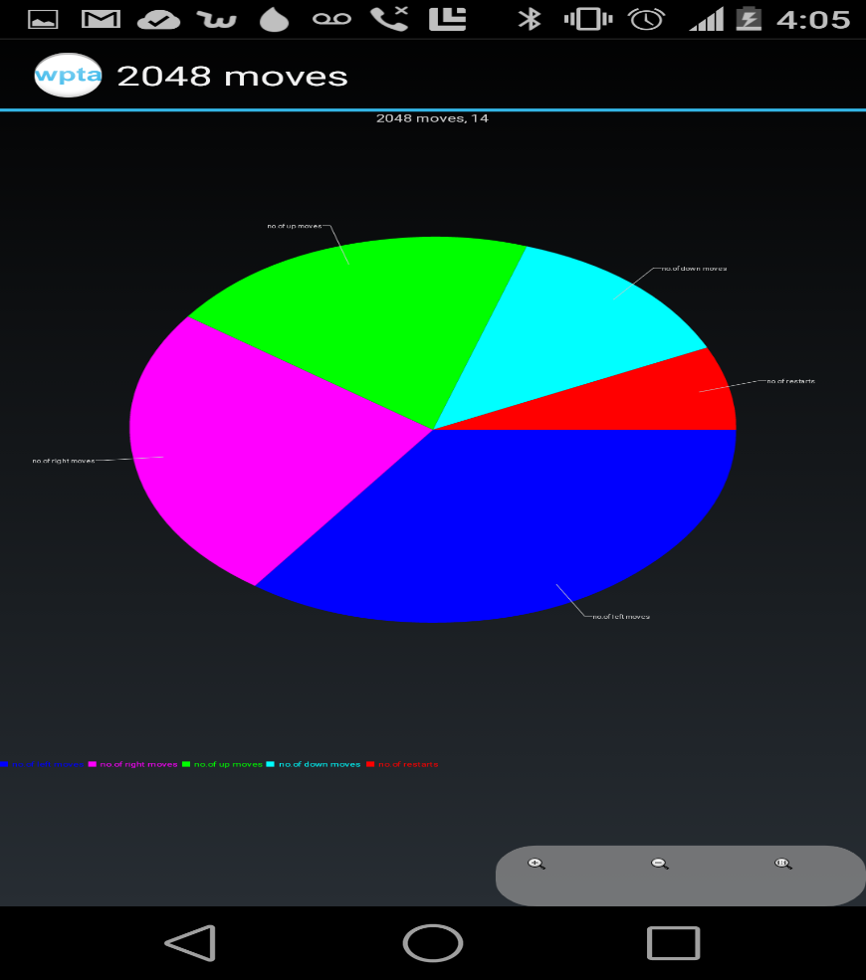

Attempts are taken on the x-axis and the type of move made by the user is taken on y-axis. Line graph is generated showing the attempts and moves made. Each number represent a particular move.



**Evaluation: Motion/Activity Recognition**

Our 2048 motion sensor app is a single player game and it can recognize five gestures like left, right, up, down, restart.

As in the above data which we have collected, we were capturing each and every move which we are making by using this we were able to find the total number of moves made by the player. We are also showing the number of unscored moves made by the player because by this data player might understand how many moves were wasted without scoring. Max response time is the maximum time taken by the player in order to make a move. We were also able to estimate the playing style of the user by using the data because in 2048 for making good score we must be able to follow a certain pattern like using only three movements in the game.

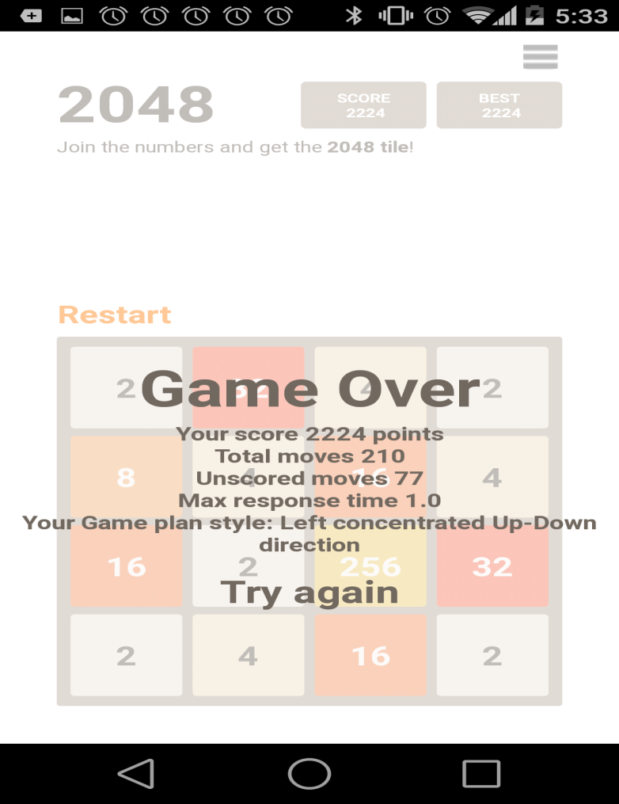

Confusion Matrix:

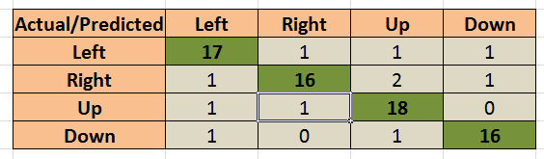

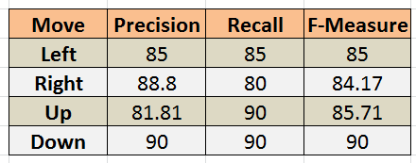

**Limitations**

* Unable to obtain 100% precision and recall.
* Right move should improve accuracy when compared to other moves

**Related Work**

* 2048 (open source android game)
* Sensor tag (Open source Android application)

**Youtube link**

<https://www.youtube.com/watch?edit=vd&v=XZsKiUg2wFU>

**Bibliography**

<http://processors.wiki.ti.com/index.php/SensorTag_User_Guide>

<http://en.wikipedia.org/wiki/2048(video_game)>

<https://github.com/uberspot/2048-android>

<https://play.google.com/store/apps/details?id=com.digiplex.game>

1. **Challenges Faced**
2. Unable to obtain 100% precision and recall.
3. Gesture recognition though complete on two earlier release wasn’t perfect for various reasons. Had to train with thrice.
4. Right move should improve accuracy when compared to other moves.
5. Time lapse(less than 1 second) in recognizing the move.
6. Line chart is congested when the data is large.
7. **Project Management**

**Project Management Report**

The idea was to develop the project along with lab course work which would give the necessary technical background to start something.

After every phase we had the plan to revisit the development from previous phases and better them, as and when we learnt new things in the lab. This being in similar lines with Scrum model of development helped us and there wasn’t much extensive effort that we had to denote for project management.

We concentrated majorly on analyzing the game better than just focusing on provide multiple add on features which gave us more time to work on the core of idea rather than diverting time to research of more and more apps and open source projects.

As per project management we were very much strict on sticking to the plan and cutting off any unwanted effort from the planned effort for a particular task. Lab work being close to what we had to develop and with help of assistance at the labs we had very little trouble managing our project.

Below are the screen shots from our ScrumDo account

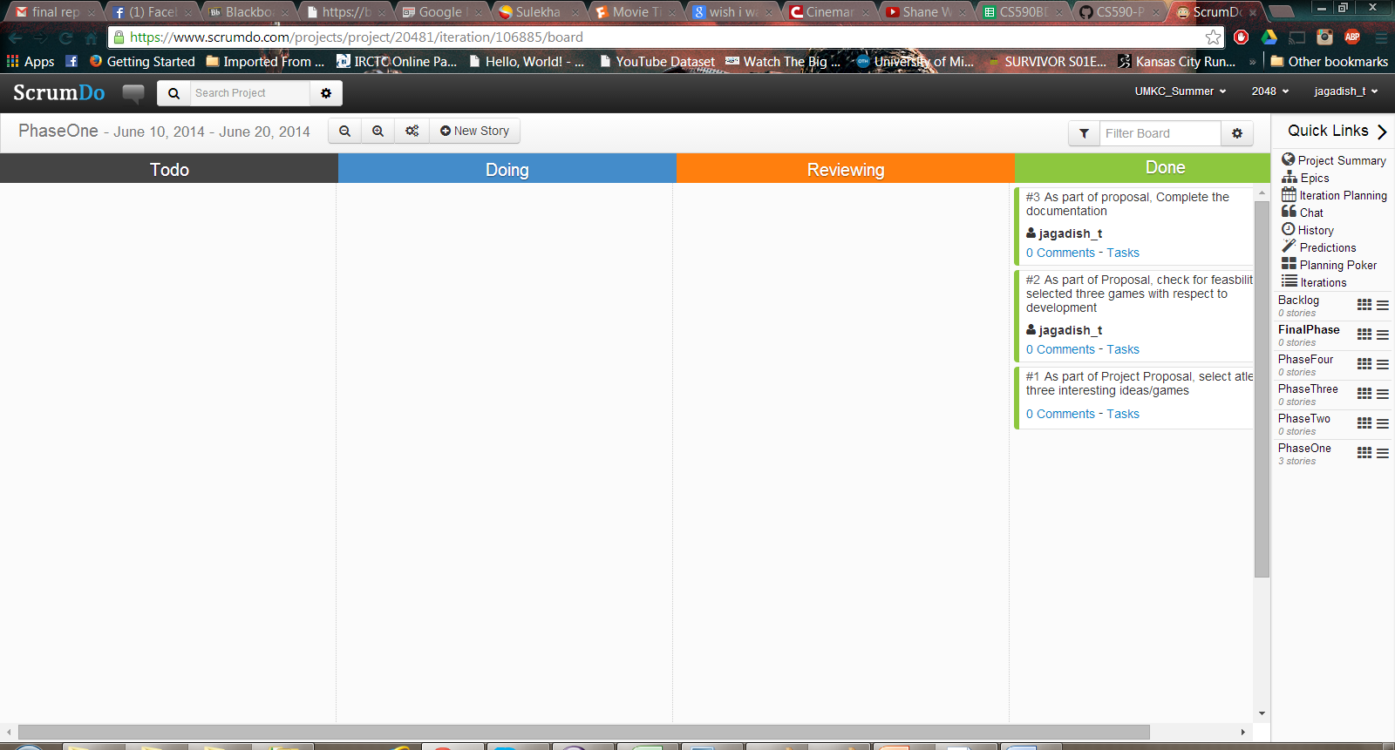

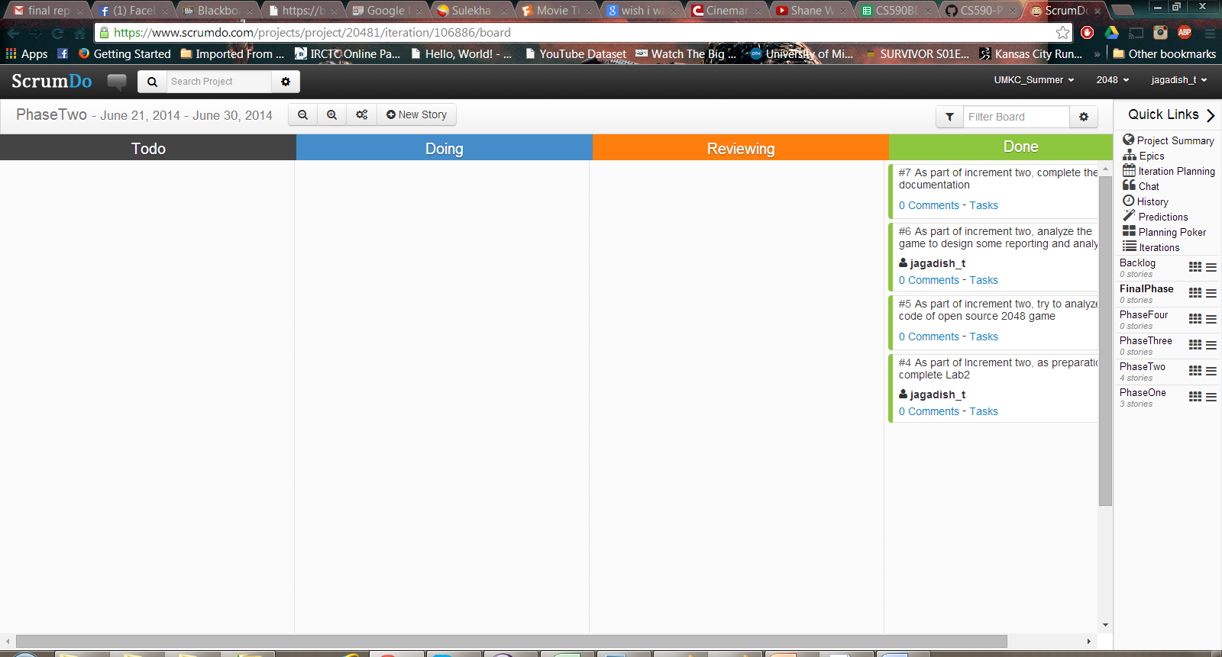

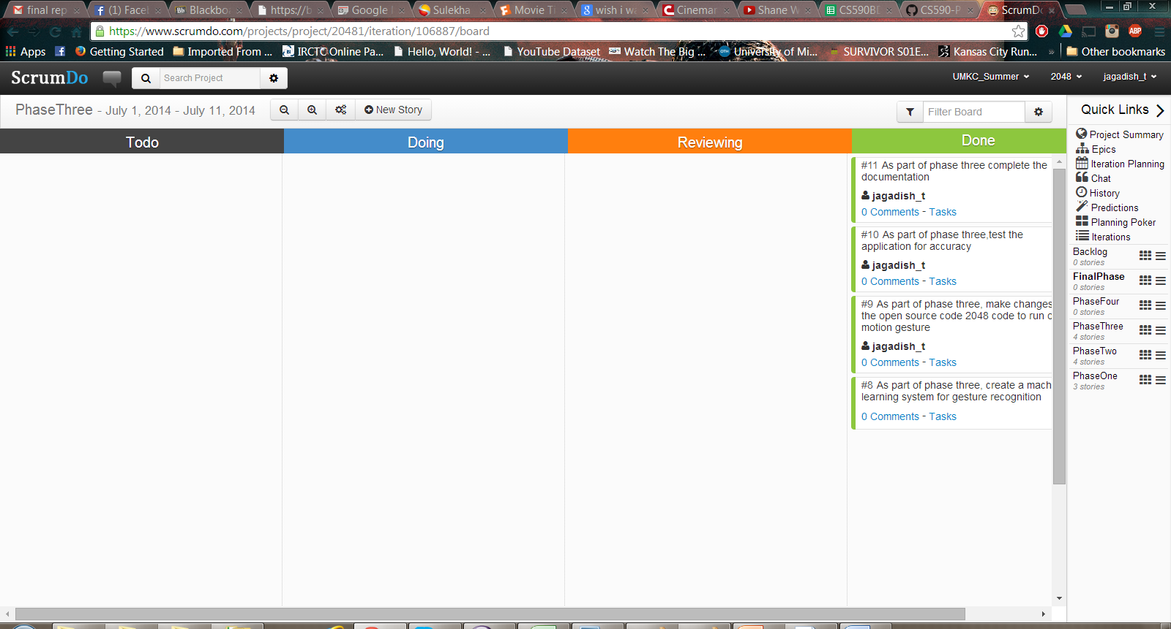

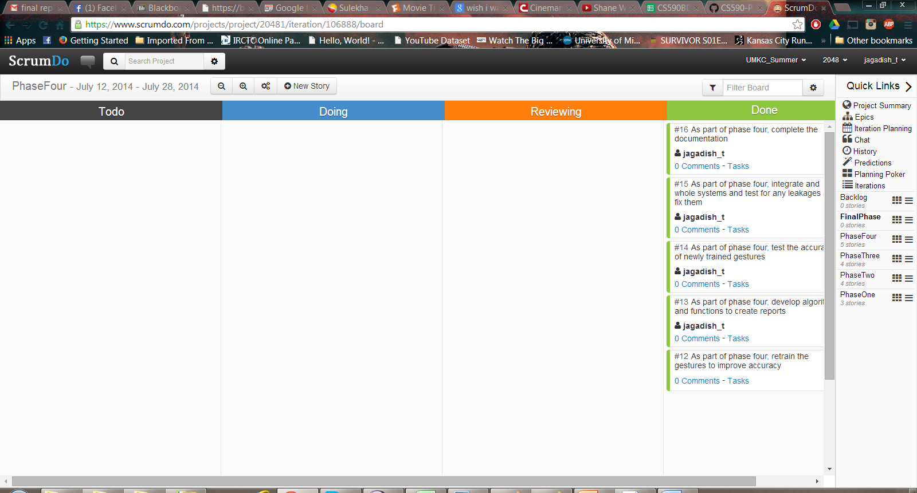

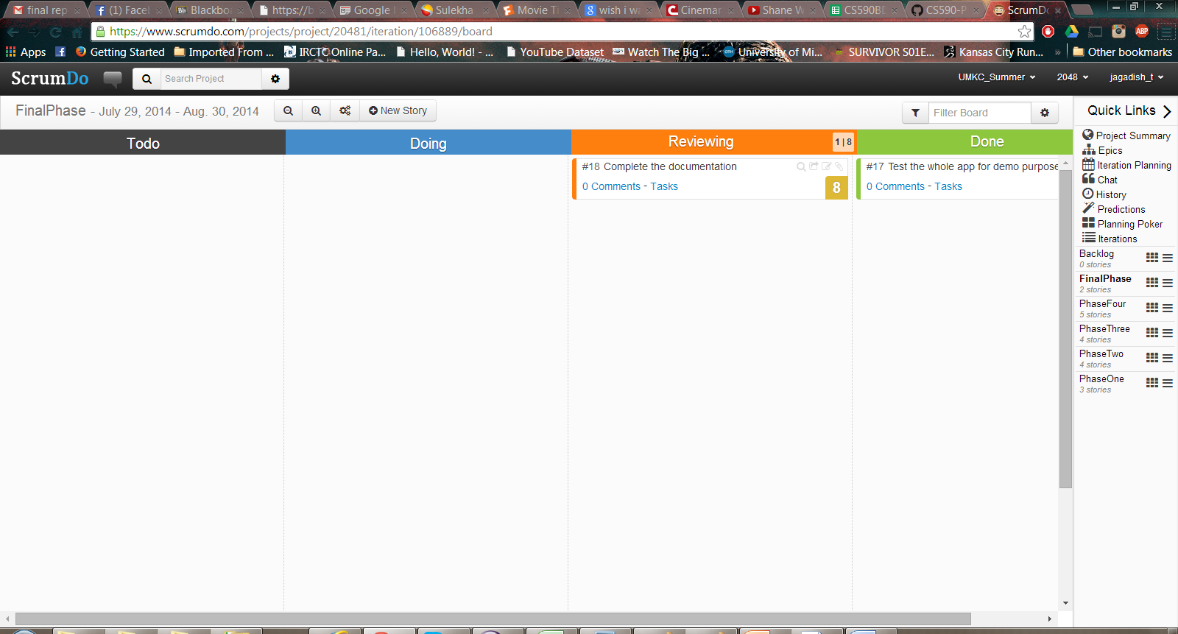

Reference**:** [**https://www.scrumdo.com/projects/project/20481/summary**](https://www.scrumdo.com/projects/project/20481/summary)

**Project Evaluation:**

As a group, we are very much satisfied with what we were able to develop as a team and how much we could take from this learning experience.

We tried our best to stay on track with what was planned to be delivered. Our main motive was to develop a gesture based game, with proper reporting and be able to predict user steps in the game.

We were able to complete the game with pretty good percentage of accuracy with respect of gesture recognition. We came up with interesting ways to analyze the game and report it to the user. One thing that we could not see reaching completion was prediction part. Though, we could have used some simpler ways and shown some move as a predicted move we chose not to as we want to take it up properly as our future work with respect to the project.

The contributions from each team member were a plenty. From discussions onto fix onto a project topic, to design and development every team member contributed their best from whatever they picked up from labs and tutorials. It was helpful at the same time motivational experience, being part of this group.

We had a simple but very strong project management idea – Rework! This really helped us connecting all the dots and tie all the loose ends together after every phase. What really helped us finish us early was Lab 5 wherein we divided ourselves into two teams and work on 2048 to improve efficiency. There after picking up from the best off the two source codes to complete our final project.

Though everything went smooth with our project, given a chance we would for sure want to revisit our design phase wherein we could have used some more hours, brain storming for the analysis part of the game and better way to approach towards more innovative ways to report to user how his brain responds when dealing with a problem.

1. **Project Deployment**

GitHub Link: <https://github.com/mlikk/BigDATA/tree/master/Project_2048/2048_final>

Project Video: <https://www.youtube.com/watch?v=XZsKiUg2wFU&list=UUgXfDCY1nqEJnqLH3TbebUQ>

1. **Presentation Material**

